Choose an operating system that best suits your preferences and project requirements. Download and Install Windows 11. <https://www.microsoft.com/software-download/windows11>

**Part 1**

Create Windows 11 Installation Media

**Download the Media Creation Tool:**

Go to the Windows 11 download page: <https://www.microsoft.com/software-download/windows11>.

Under the "Create Windows 11 Installation Media" section, click "Download now".

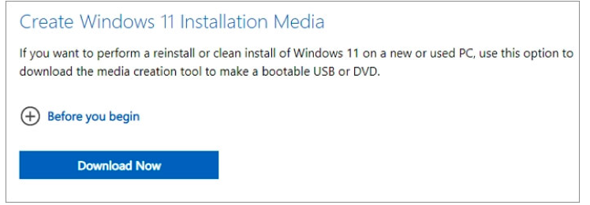

**Run the Media Creation Tool:**

* Open the downloaded Media Creation Tool executable file.
* Accept the license terms.

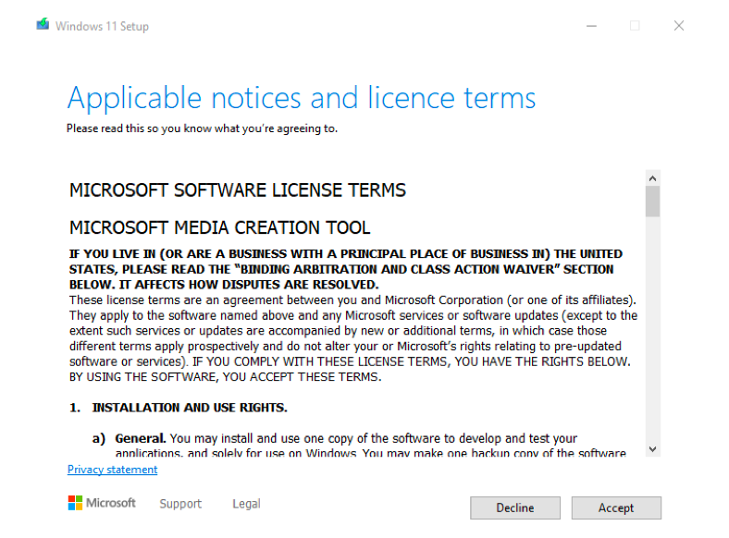

**Set Up the Media Creation Tool:**

Choose the language, edition, and architecture (64-bit) and press next.

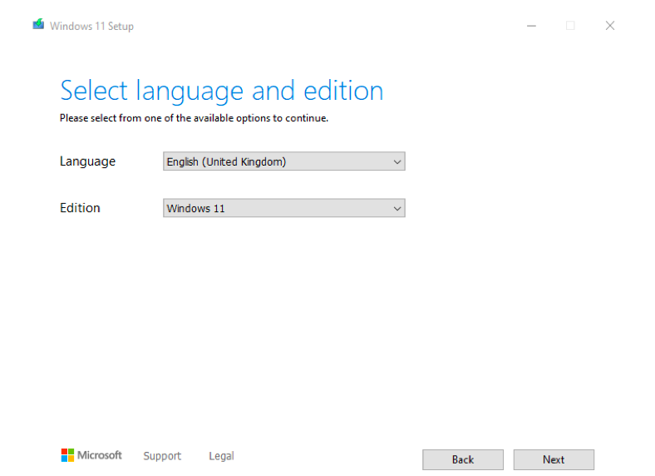

Select "USB flash drive" as the media to use. Alternatively, you can choose "ISO file" if you want to create a bootable DVD.

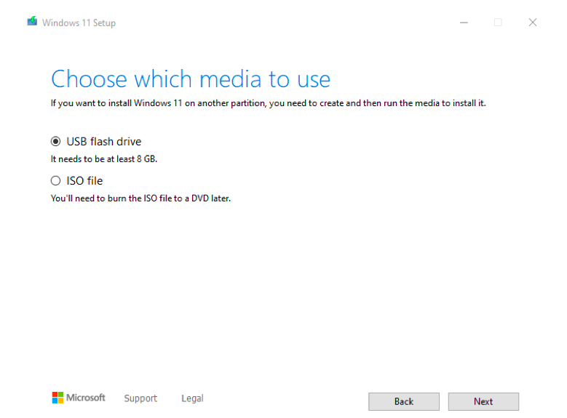

**Create the Installation Media:**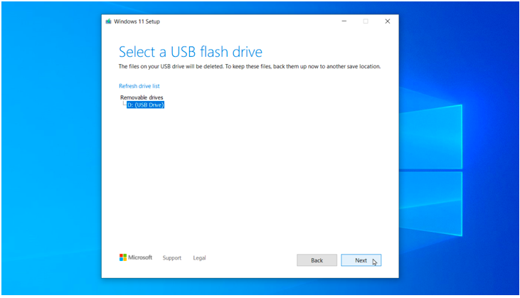

Insert a USB flash drive with at least 8 GB of storage.

Select the USB drive from the list and click "Next".

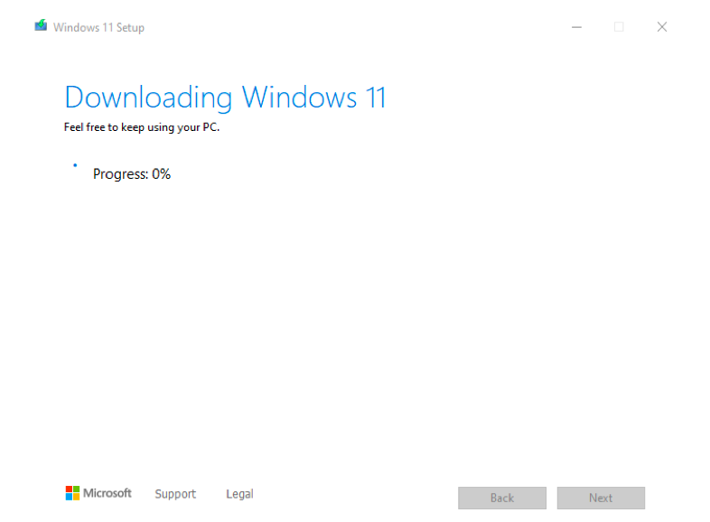

The tool will download Windows 11 and create the bootable USB drive.

After that click finish

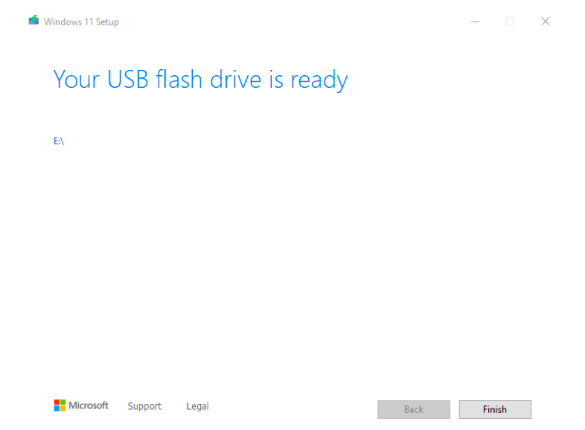

Install Windows 11 Using the Installation Media

**Part 2:**

**Prepare Your PC:**

* Back up all important data.
* Ensure your PC meets the Windows 11 system requirements.

**Boot from the USB Drive:**

* Insert the bootable USB drive into your PC.
* Restart your PC and enter the BIOS/UEFI settings (commonly accessed by pressing a key like F2, F12, Delete, or Esc during startup).
* Change the boot order to boot from the USB drive first.

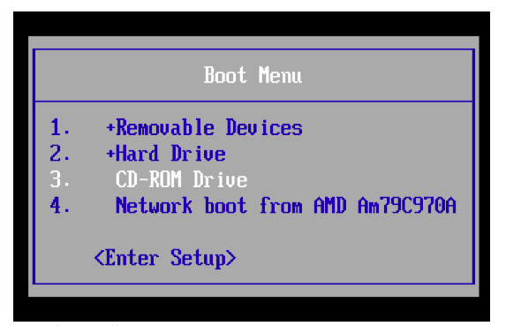

**Start the Installation Process:**

Save the changes and exit the BIOS/UEFI settings. Your PC should now boot from the USB drive.

The Windows Setup screen will appear. Select your language, time, and keyboard preferences, and click "Next".

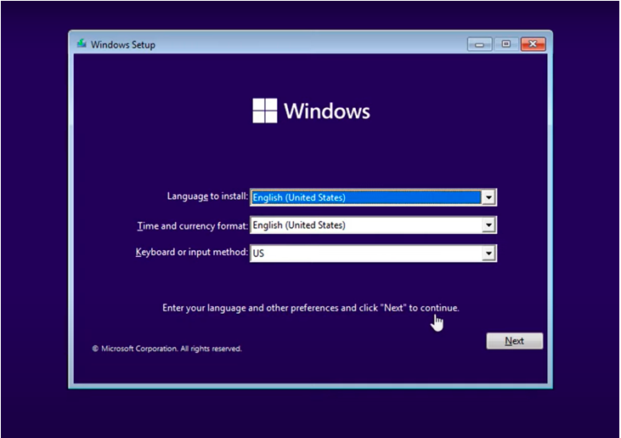

Click "Install now".

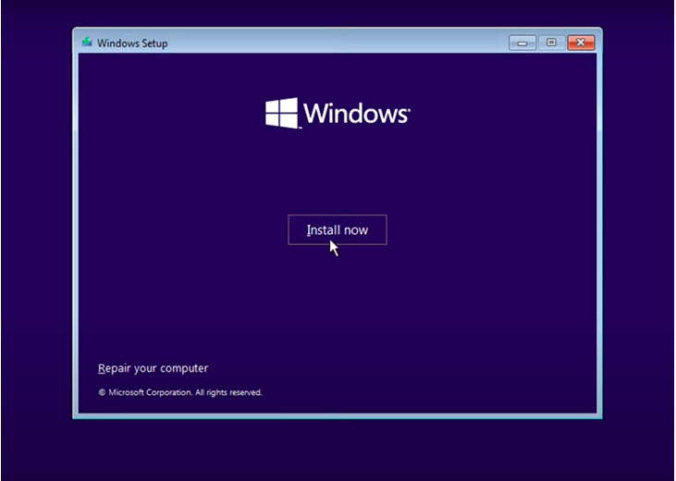

**Enter Product Key:**

If prompted, enter your Windows 11 product key. If you are upgrading from Windows 10, you may skip this step as the activation should be automatic.

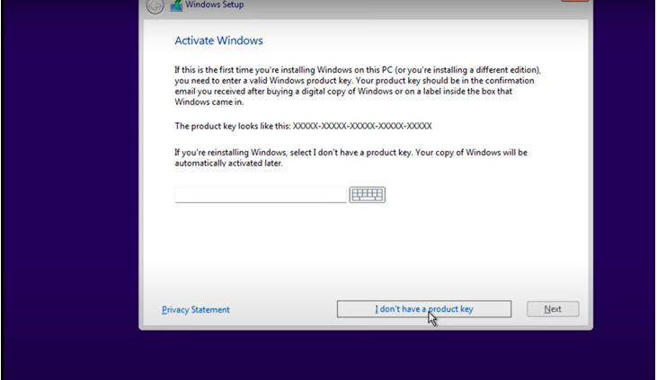

**Select Installation Type:**

Choose "Custom: Install Windows only (advanced)" for a clean installation.

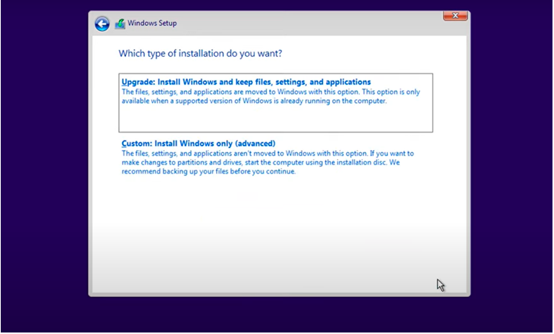

choose windows type and click next.

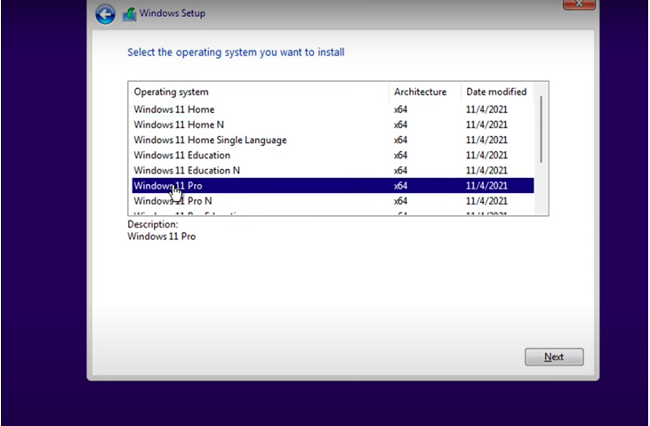

**Partition the Drive:**

Select the partition where you want to install Windows 11. You can delete existing partitions to create a new one, but this will erase all data on the selected partition.

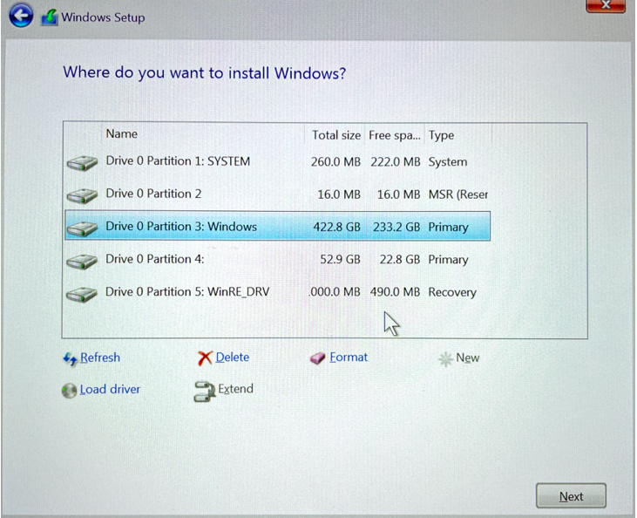

Click "Next" to start the installation.

Complete the Installation

**Follow On-Screen Instructions:**

Windows 11 will now be installed on your PC. The process might take some time and your PC will restart several times.

**Set Up Windows 11:**

After installation, you will be guided through the initial setup process. Configure your preferences, sign in with your Microsoft account, and set up any additional settings.

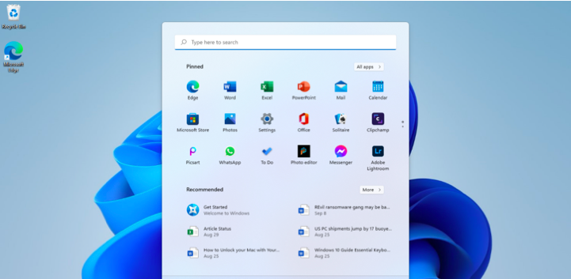

**Install a Text Editor or Integrated Development Environment (IDE):**

Select and install a text editor or IDE suitable for your programming languages and workflow. Download and Install Visual Studio Code. <https://code.visualstudio.com/Download>

Steps to Download and Install VS Code on Windows

**Download VS Code:**

* Go to the Visual Studio Code download page: <https://code.visualstudio.com/Download>.
* Under the "Download Visual Studio Code" section, click "Download for Windows".
* This will start the download of the VS Code installer (VSCodeUserSetup-x64-1.X64-1.XX.X.exe).

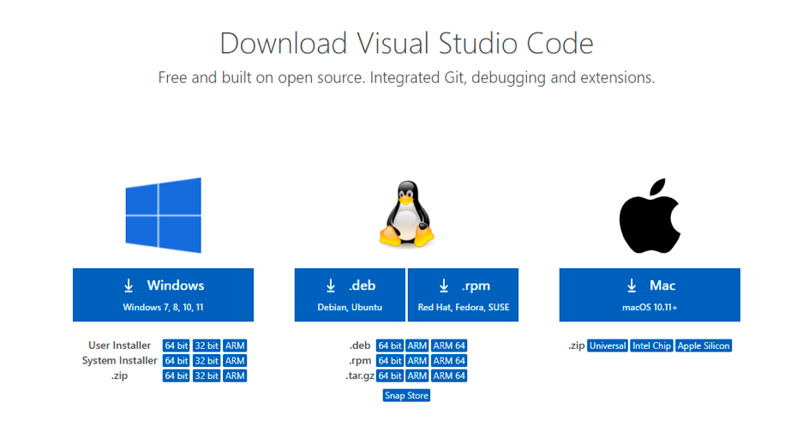

**Run the Installer:**

* Open the downloaded VS Code installer.
* Run the VS Code installer (VSCodeUserSetup-x64-1.X64-1.XX.X.exe).
* The installer wizard will appear.

Installation Prompt:

* **Accept** the license agreement and click next.

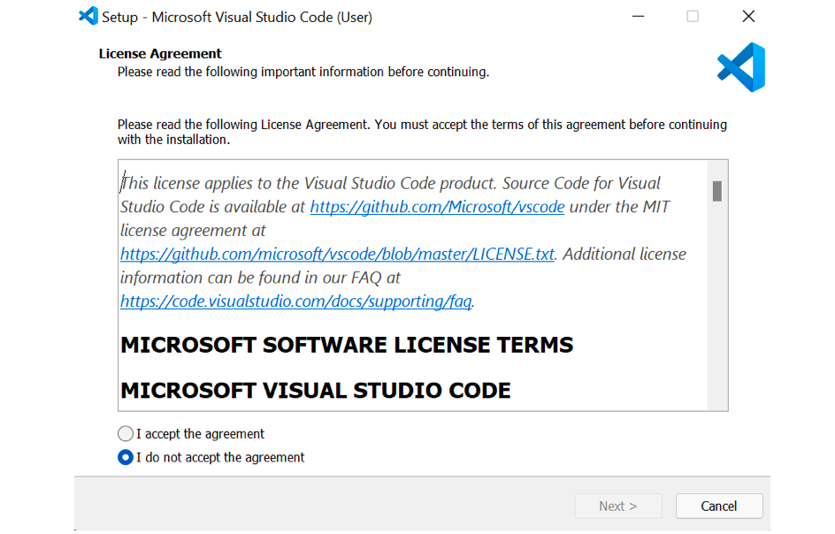

* Choose the location where you want the VS Code installation to be kept. Accept the default location and click next.

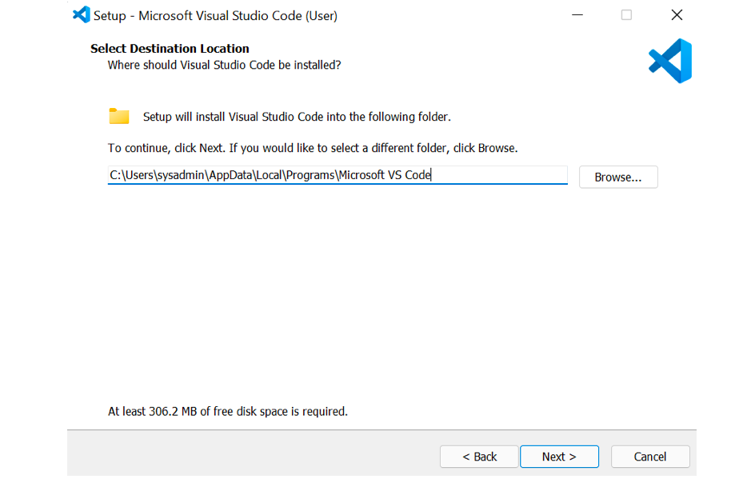

Accept the default Start Menu Folder and click Next.

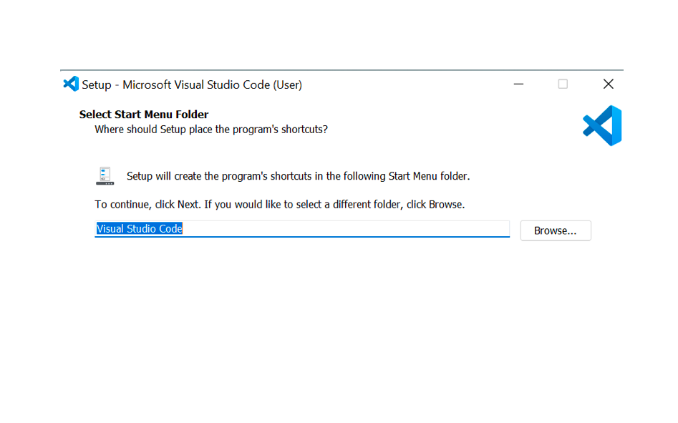

**Select additional tasks (optional but recommended):**

* Click on Create a Desktop icon.
* Click on Add to path (important to use the command line).
* Click register code as an Editor for supported files.
* Adding “Open with Code” action to the Windows Explorer context menu.
* Adding “Open with Code” to the directory context menu.
* Click next.

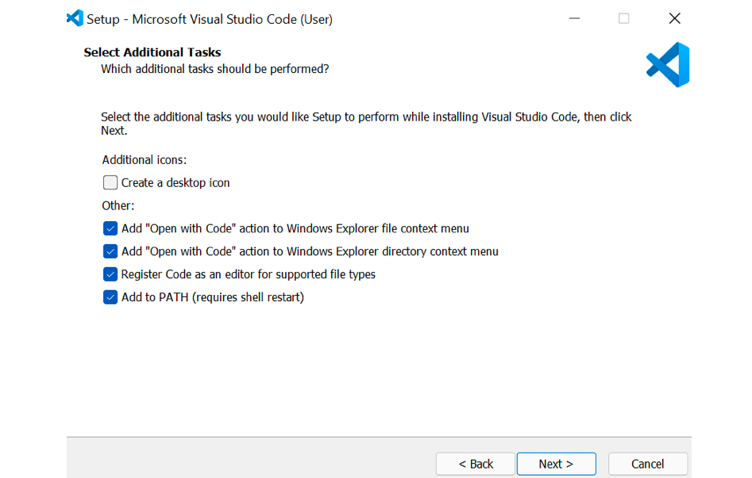

* The installation will begin. Click on the install button.
* After clicking install, it should take about one minute to install VS Code on your device.

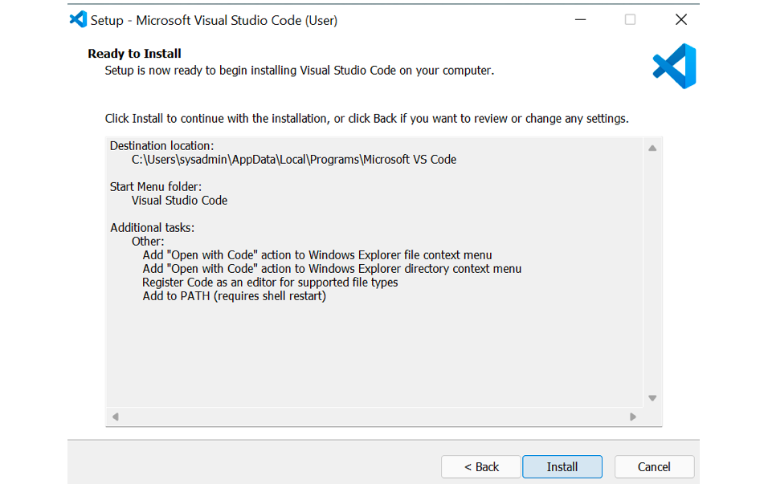

**Finish Installation:**

After installation, a setup window will appear. Tick on Launch VS Code and click Finish.

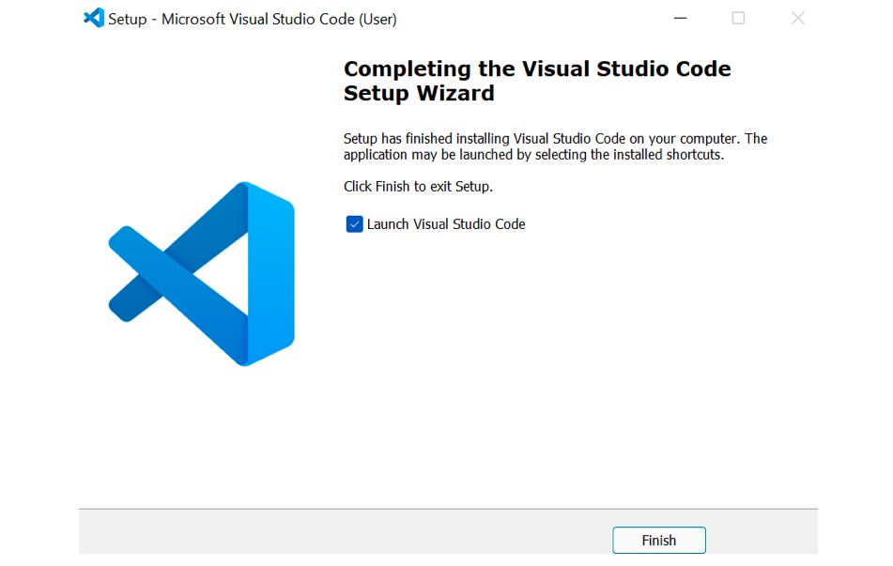

**Set Up Version Control System:**

* Install Git and configure it on your local machine. Create a GitHub account for hosting your repositories. Initialize a Git repository for your project and make your first commit. [https://github.com](https://github.com/)
* sample Repo with git ignore: <https://github.com/Johnnytash/this-is-a-test-repo.git>.

**Step 1: Download and Install Git**

**Download Git for Windows:**

* Go to the Git download page: <https://git-scm.com/downloads> and download the latest version for your operating system.

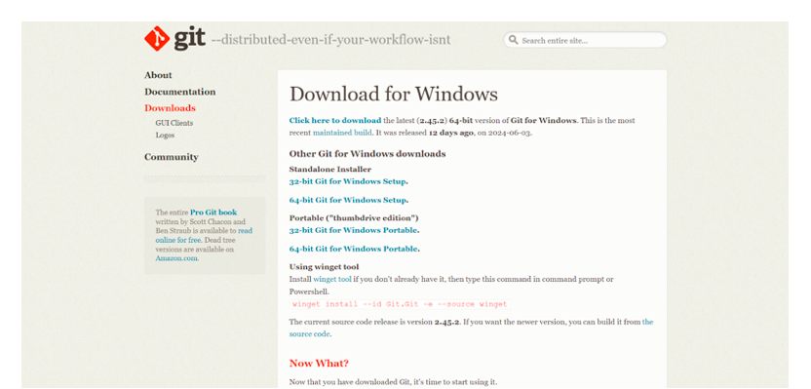

**Run the Installer:**

* Open the downloaded Git installer.
* Run the Git installer (Git-2.38.0-64-bit.exe).
* The installer wizard will appear.
* Accept the license agreement and click next.

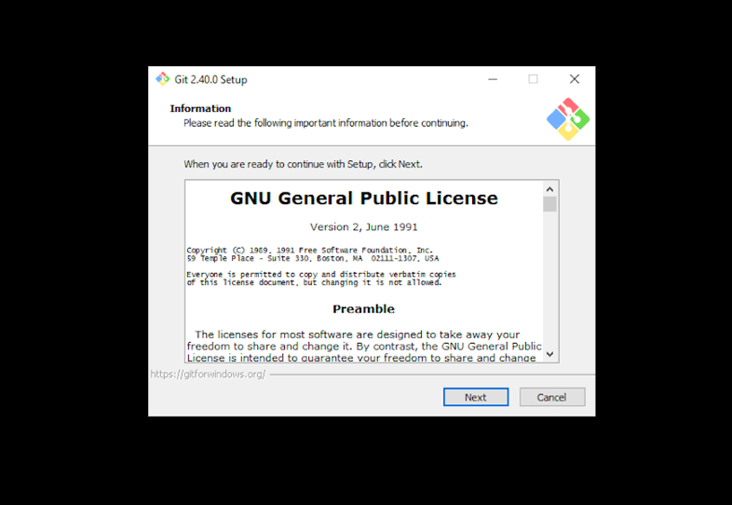

choose the location where you want the Git installation to be kept. Accept the default location and click next.

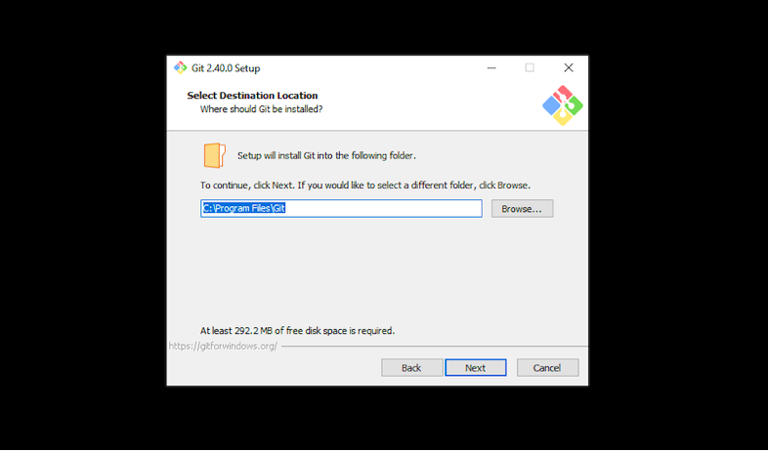

**Follow the Installation Wizard:**

Choose the default options or customize the installation according to your preferences. Some **key settings to note:**

* Adjusting your PATH environment.
* Choosing the HTTPS transport backend.
* Configuring the line-ending conversions.
* Choosing the default Git editor.

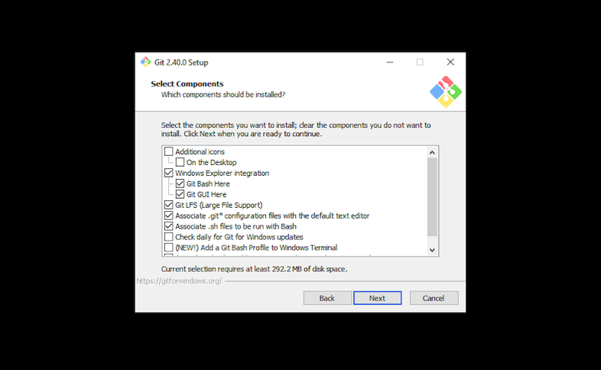

**Start folder:**

You’ll be prompted to create a start folder. Leave it as is and click Next.

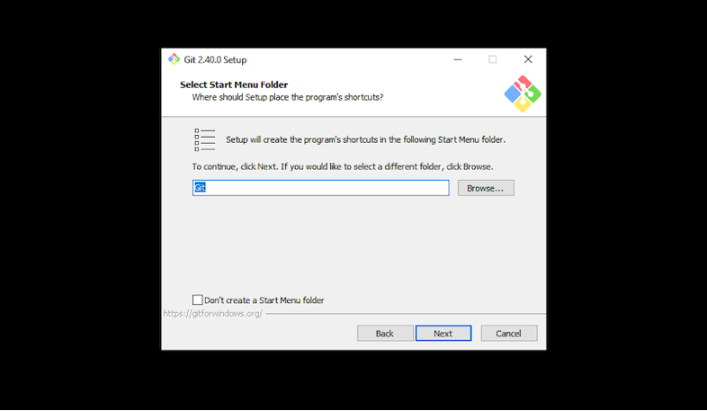

**Text editor:**

* Choose a text editor to use with Git. Click on the drop-down menu to pick the text editor you like to use like Vim, Notepad++, etc, and click Next.

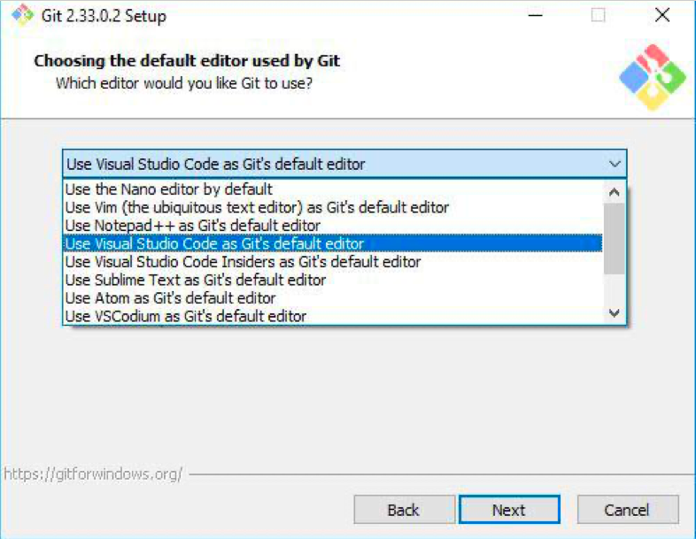

In the next steps choose all default options and click finish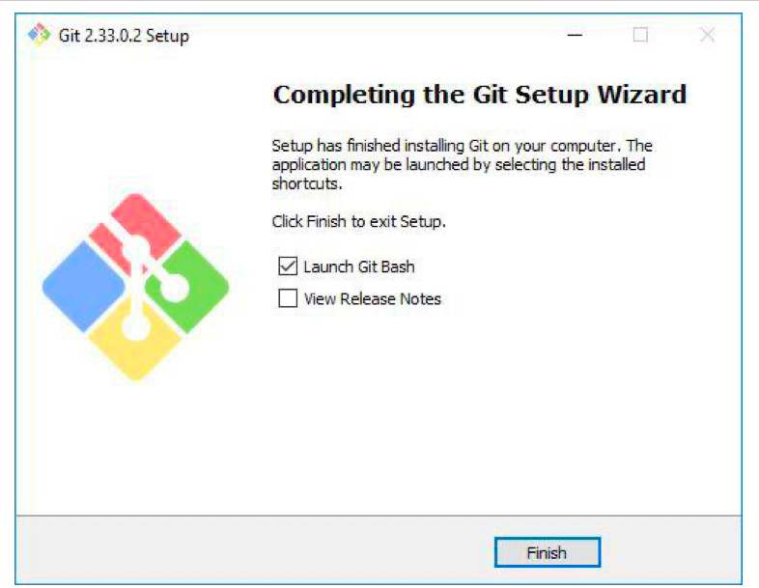

**Step 1: Verify the Installation**

Open Command Prompt or Git Bash and run git –version

IMAGE OF GIT VERSION ON TERMINAL HERE

**NEXT: Configuring Git**

* Open a terminal or command prompt (Git Bash).
* Set your username and email: [git config --global user. name "Your Name"] [git config --global user.email "[your.email@example.com](mailto:your.email@example.com)"]

**NEXT: Create a GitHub Account**

Sign up for a GitHub account at GitHub. [https://github.com](https://github.com/)

Enter your information:

* Unique username
* Email address
* Password
* Confirm password
* Create GitHub account
* Click on the link to verify your email address.

**NEXT: Initialize a Git repository**

**Create a new repository on GitHub:**

* Go to your GitHub profile page and click on your profile picture.
* Go to your profile.
* Click on your repositories.
* Click on “Create new repository”.

**NEXT: Fill in the details:**

* Repository name
* Repository description
* Select “Public”
* Select “Initialize this repository with a README”(optional)
* Add .gitignore (optional)
* Click on “Create repository”.
* Choose a license (optional)
* Click "Create repository"

PUT REPOSITORY IMAGE HERE

**NEXT: Cloning Git Repository**

* Copy the repository URL from the GitHub page.
* Open Git Bash or Command Prompt.
* Run git clone PUT SAMPLE REPOSITORY URL HERE
* Navigate to the cloned repository and run git status to check if the repository is cloned successfully.
* verify the cloning with the ls command

**NEXT: Commit and Push Changes**

* Create a new file: [touch example.txt]
* Add content to the file: [nano example.txt]
* Save and exit the editor (for nano, press Ctrl+X, then Y, and Enter).

INSERT IMAGE HERE OF THE TERMINAL WITH STEPS ABOVE

* Check the status of your repository: [git status]
* Add the new file to the staging area: [git add example.txt]
* Commit the changes: [git commit -m "Add example.txt"]
* Push the changes to the remote repository: [git push -u origin master]

INSERT IMAGE OF TERMINAL WITH STEPS ABOVE HERE

git ignore file

IMAGE OF TERMINAL WITH GIT IGNORE HERE

* Install Necessary Programming Languages and Runtimes: Python, Dart, and Flutter SDK.
* Install Python from [http://wwww.python.org](http://wwww.python.org/) programming language required for your project and install their respective compilers, interpreters, or runtimes. Ensure you have the necessary tools to build and execute your code.

**PYTHON INSTALLATION step1:** Download python installer

Go to <https://www.python.org/downloads/>

Download the latest version of Python for Windows.

Select the installer that corresponds to the version of Python you want to install.

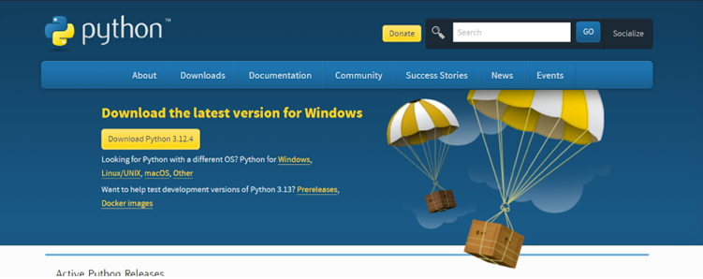

**NEXT: Run the installer**

* Open the downloaded installer file.
* Run the installer.
* Check the box that says "Add Python to PATH".
* Click "Install Now".

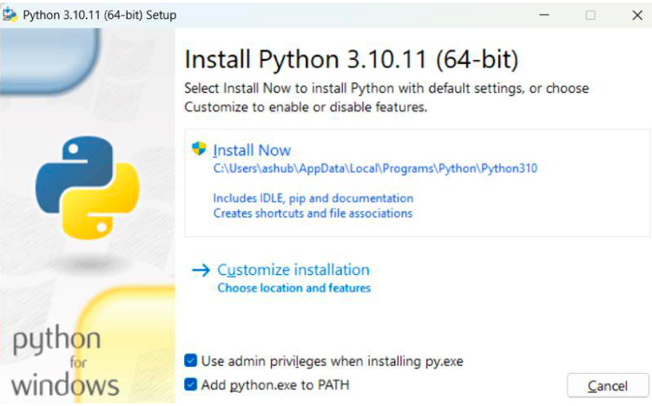

**NEXT: Verify Installation**

* Open Command Prompt or Git Bash.
* Run python --version

Verify the installation by checking the version number.

IMAGE OF PYTHON VERIFICATION HERE

**DOWNLOADING DART**

**Step 1: Visit the Dart SDK Download Page:**

* Go to <https://www.dartlang.org/downloads>
* Download the latest version of Dart for Windows.
* Select the installer that corresponds to the version of Dart you want to install.

**NEXT: Install Dart SDK on Windows**

* Download the Dart SDK:
* Click on the "Download Dart SDK" button for Windows.
* Choose the .zip file for Windows and download it.

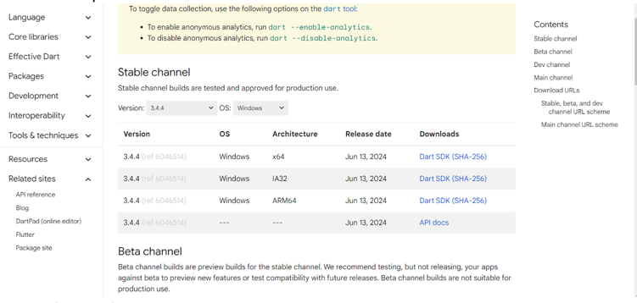

**Extract the ZIP File:**

Extract the downloaded ZIP file to a desired location on your computer, e.g., C:\dart-sdk.

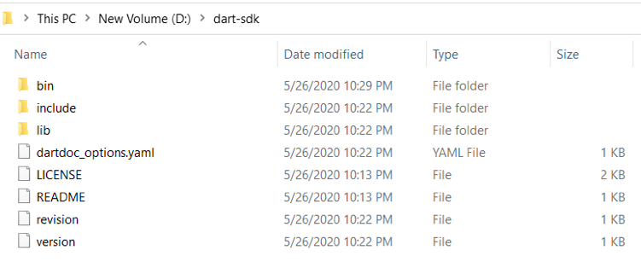

**Update Your PATH Environment Variable:**

Open the Start Search, type in env, and select "Edit the system environment variables".

In the System Properties window, click on the "Environment Variables" button.

In the Environment Variables window, find the Path variable in the "System variables" section, select it, and click "Edit".

Click "New" and add the path to the bin directory inside the extracted Dart SDK folder (e.g., C:\dart-sdk\bin).

Click "OK" to close all the windows.

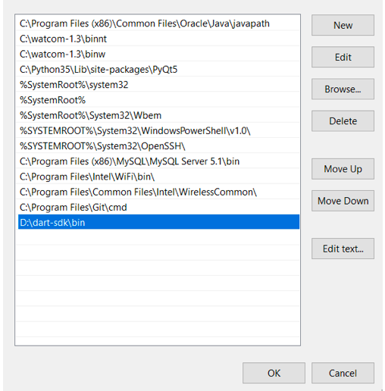

**NEXT: Verify Dart Installation**

Open Command Prompt or Git Bash.

Run dart --version

Verify the installation by checking the version number.

IMAGE OF DART VERIFICATION ON TERMINAL HERE

**DOWNLOAD FLUTTER SDK**

**Steps: System Requirements:**

Windows 10 or later(64-bit).

Disk Space: 1.64 GB (not including disk space for IDE/tools).

Tools: Flutter depends on these tools being available in your environment.

Git for Windows

The choco command, if you use Chocolatey for package management

**NEXT: Download Flutter SDK:**

Go to <https://flutter.dev/docs/get-started/install/windows>

Download the latest version of Flutter for Windows.

Select the installer that corresponds to the version of Flutter you want to install.

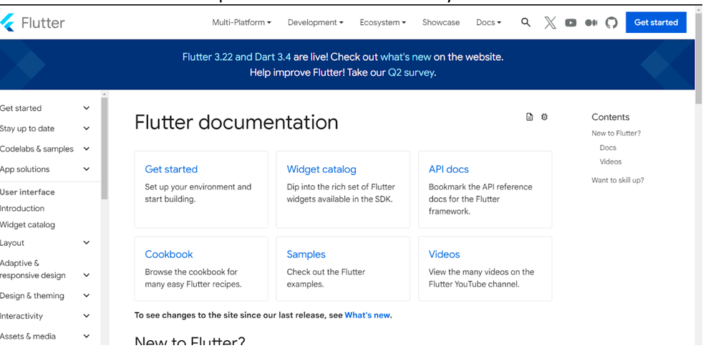

**NEXT: Install Flutter SDK on Your Operating System**

Download the Flutter SDK:

Click on the "Download Flutter SDK" button for Windows.

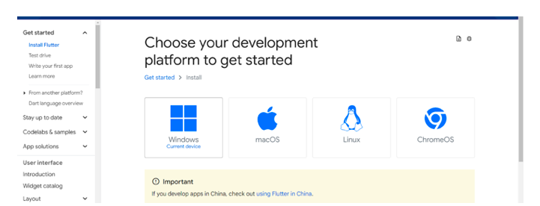

Choose the .zip file for Windows and download it.

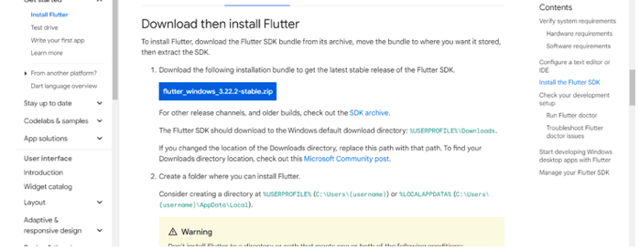

Extract the ZIP File:

Extract the downloaded ZIP file to a desired location on your computer, e.g., C:\flutter-sdk.

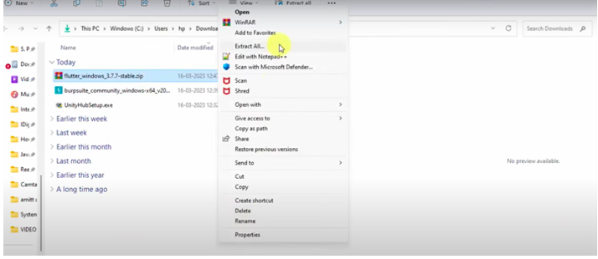

**Update Your PATH Environment Variable:**

* Open the Start Search, type in env, and select "Edit the system environment variables".
* In the System Properties window, click on the "Environment Variables" button.
* In the Environment Variables window, find the Path variable in the "System variables" section, select it, and click "Edit".
* Click "New" and add the path to the bin directory inside the extracted Flutter SDK folder (e.g., C:\flutter-sdk\bin).
* Click "OK" to close all the windows.

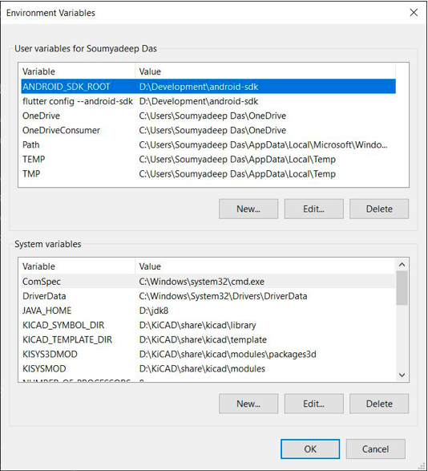

**Verify Flutter Installation**

* Open Command Prompt or Git Bash.
* Run flutter --version
* Verify the installation by checking the version number.

IMAGE OF YOUR TERMINAL RESULT OF FLUTTER VERSION HERE

**Run Flutter Doctor:**

Type flutter doctor and press Enter.

This command checks your environment and displays a report of the status of your Flutter installation. Ensure all required dependencies are installed.